1. Format the Excel File in the A and B columns (unique identifier and query sequence) as follows:

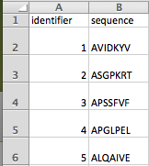

1. In column C, use the concatenate command as follows, making sure the highlighted boxes are corresponding to the correct cell.

=CONCATENATE(“>”,A2, “ ”, CHAR(13),B2)

\*\*\*Use CHAR(10) for Windows and CHAR(13) for Mac devices.

After entering and producing a value, hover over bottom right corner of cell and drag down to apply the formula to all sequences.

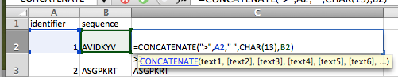

1. Highlight all of column C and under the Home tab, click on “Wrap Text” which should make the output go from a single line of text to what is formatted as follows:

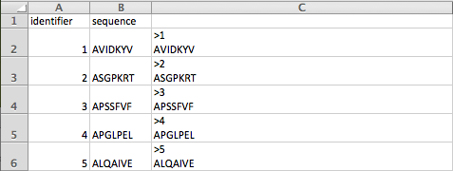

1. Highlight all of column C and copy and paste it into a Word document. Save this file with an appropriate name and save it as Plain text (.txt).

If you wish to use these sequences on the BLAST+ app to BLAST all sequences in a batch, save it into a created folder called sequences on the blastdb folder in your home directory (USER/blastdb/sequences).

This step of copying and pasting into a Word document is necessary because if the column is copy and pasted straight into a text file, there are unnecessary quotes that show up in the format. This step eliminates the quotes.

This is an example of what the Word document should look like.

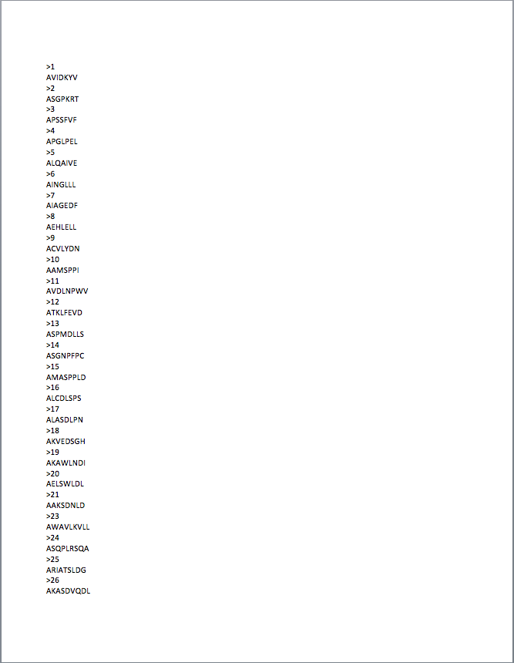

1. Locate it on the computer and replace .txt with .fasta. Save changes. Open the file if you wish to check for correct formatting. It should look like the following, which is correct FASTA formatting.

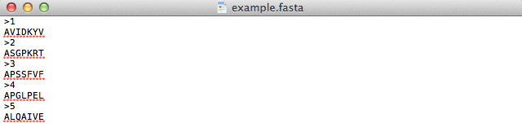

1. You are ready to use the BLAST+ app with your FASTA file now!